# Create Dashboards

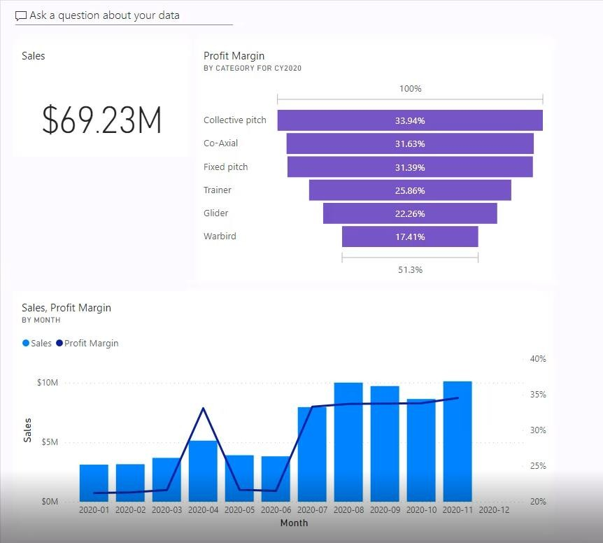

## Create a dashboard

1. In Power BI Desktop, publish the **Sales Analysis** report to the new workspace.
2. Once published, return to the Power BI service.
3. Open the **Sales Analysis** report, and then ensure the **Year** slicer is set to **CY2020**.

## Pin report visuals

1. Pin the line and stacked column chart to create a new dashboard named **Sales Monitoring**.
2. Pin the funnel chart to the new dashboard.
3. Open the **Sales Monitoring** dashboard.
4. Edit the details of the **Profit Margin** tile and modify the subtitle text to include the year (CY2020).

## Add Q&A tile

1. Use Q&A on the dashboard to ask the following question: **Total sales in CY2020**
2. Pin the response to the dashboard.
3. Show how to resize and reposition the tiles.